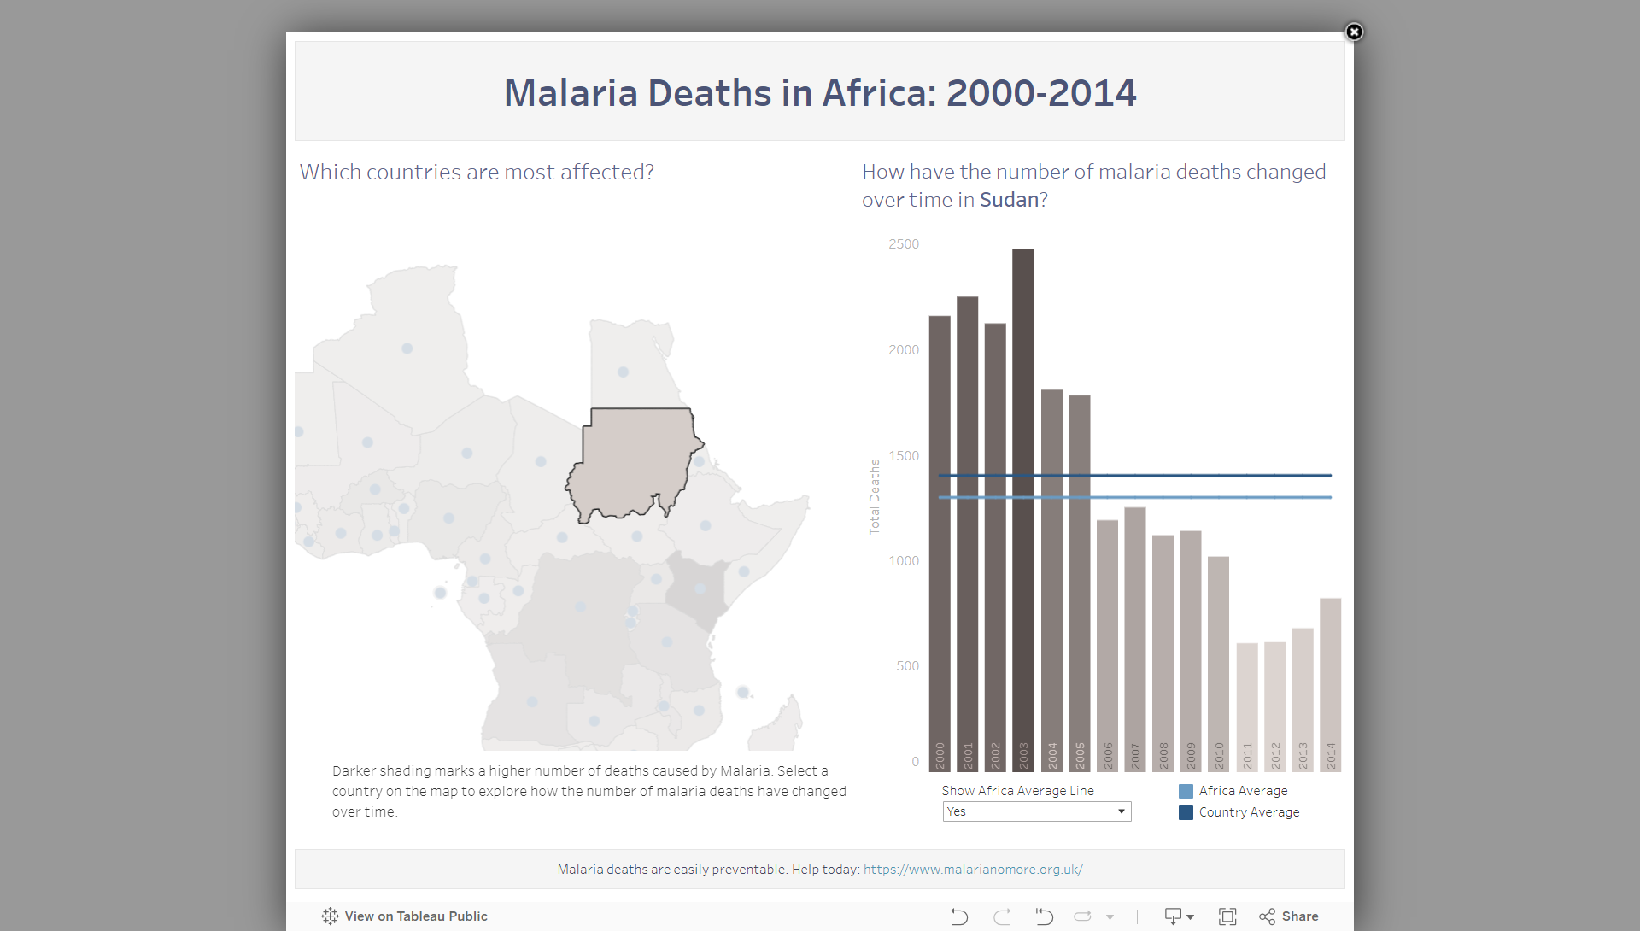

### **Report: Malaria in Sudan**

I clicked on Country Sudan in the dashboard and based on the insight provided

#### **Observations**

1. **Malaria Incidence in Sudan: Sudan has consistently experienced high rates of malaria incidence, particularly in rural areas. The data indicates that malaria remains a major concern, with infection rates among the highest in Africa..**
2. **Malaria Mortality: The mortality rates due to malaria in Sudan are concerning. The Tableau visualization highlights that the number of death has decreased over the years but still high and more than the africa average line all over the years which indicate that health system in sudan not stable.**

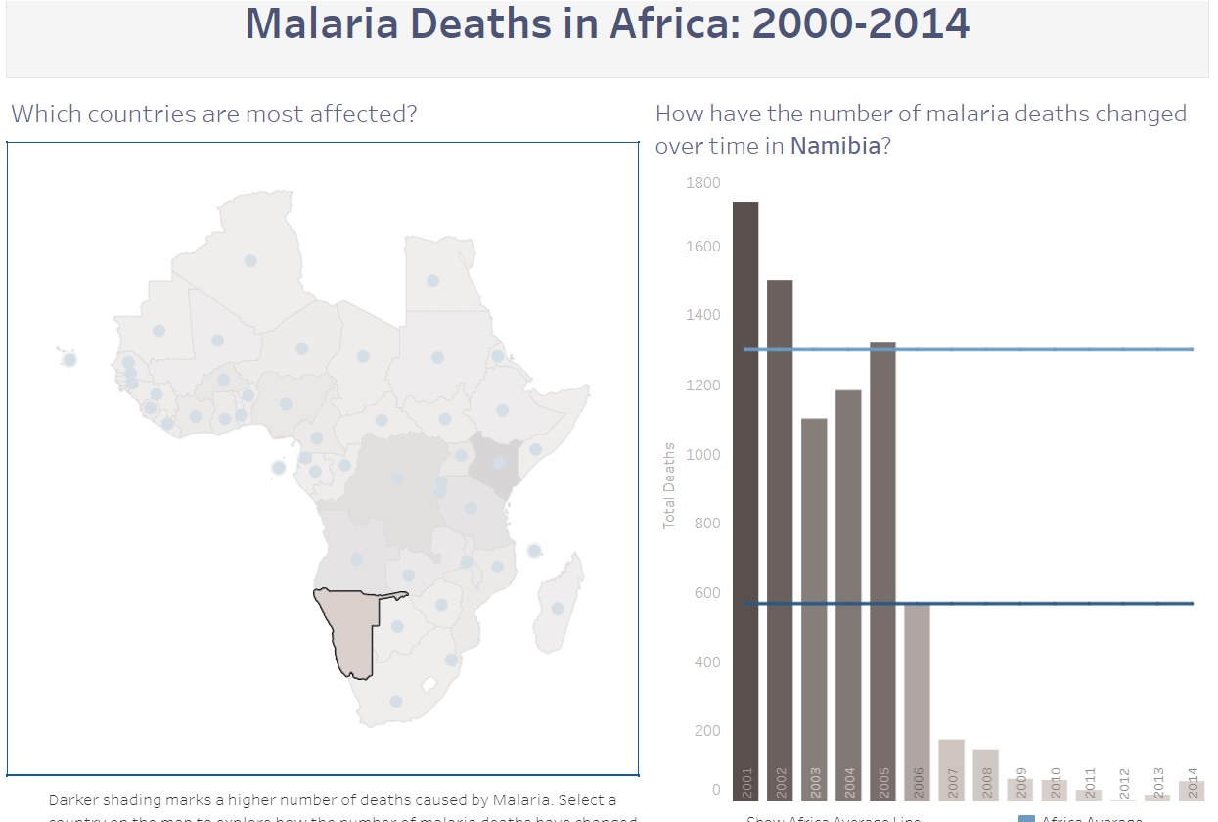

### **Report: Malaria in Namibia**

I clicked on Country Namibia in the dashboard and based on the insight provided

#### **Observations**

* **Malaria Incidence in Namibia: The incidence of malaria in Namibia varies, with the northern regions being the most affected. While Namibia has achieved significant reductions in malaria cases overall.**
* **Malaria Mortality: The number of malaria-related deaths in Namibia has decreased over years.**

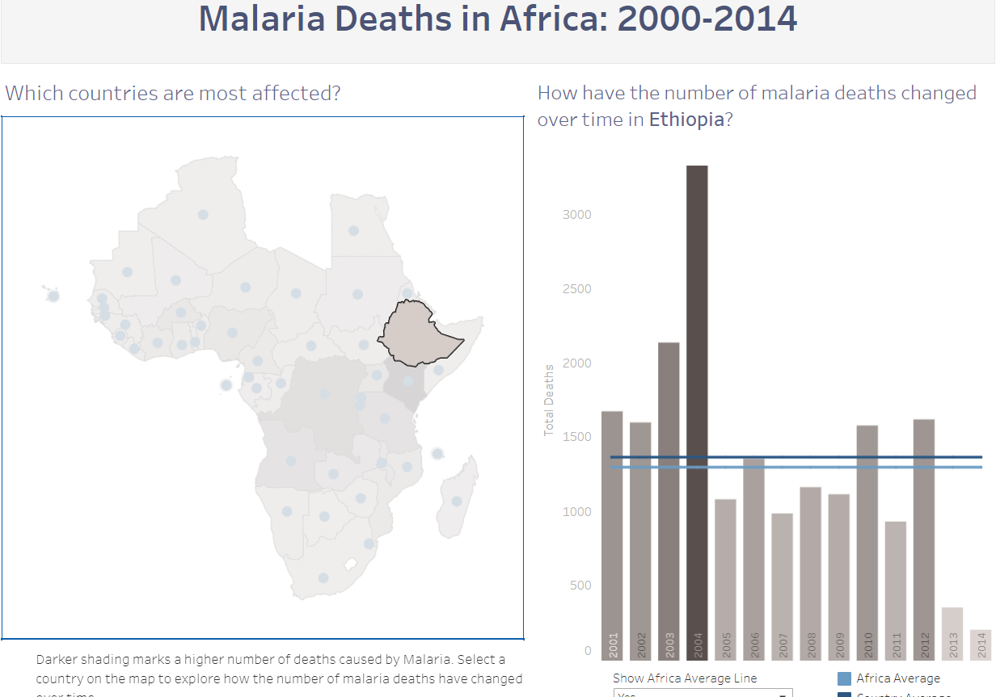

### **Report: Malaria in Ethiopia**

I clicked on Country Ethiopia in the dashboard and based on the insight provided

#### **Observations**

* **Malaria Incidence in Ethiopia: The malaria incidence in Ethiopia has a slight decreasing over the years, but certain regions still face a high burden of the disease.**
* **Malaria Mortality: The number of malaria-related deaths in Ethiopia has increased in 2004 more than Africa's average line.**